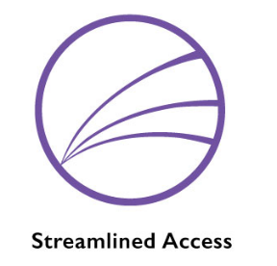
Service Recommendation

Closed on Assignment Service Completed

Service Extension Service Continuation

Case Manager/Agency: Date:

Client Name: DOB:

Address: Phone Number(s):

Date of Enrollment in Case Management:

Has an Extension or Continuation been granted before? If yes, how many?:

Alerts (safety concerns, important support needs):

*If requesting an extension or continuation, submit this form 1 month prior to possible discharge* *Also to ensure submissions will be reviewed on Fridays, submit this form by Thursday at noon*

Closed on Assignment (reason file was closed):

Service Completed (brief description of support provided):

LOCUS Score: Prior to discharge OCAN completed?

Service Extension Request (description of goals still needing to be addressed and plan to address them):

LOCUS Score: Length of service extension request (1-3 months):

Service Continuation Request (description of goals still needing to be addressed and plan to address them):

LOCUS Score: Length of service continuation request (3-6 months):

Please forward this form to: nvandenelzen@yssn.ca

